AEEA 2018 EE Expo
STEM to the Next Gen
Tuesday, June 12, 2018
Mount Magazine State Park, AR
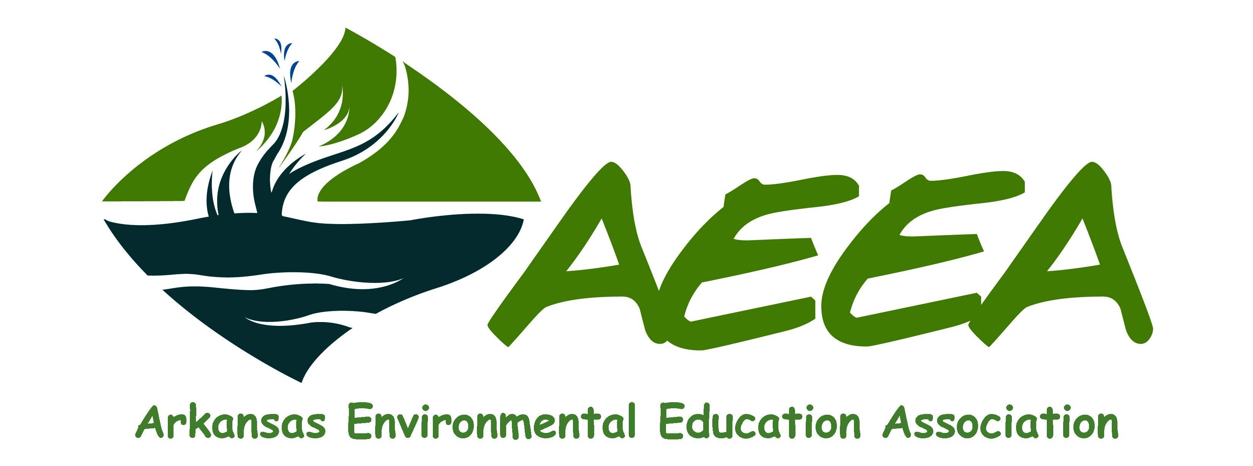
AEEA is a networking, information-based organization working with educators, students, businesses, government and concerned citizens to increase awareness and knowledge about the environment.
AEEA’s purpose is to advocate environmental education (EE), incorporating several disciplines. The EE
Expo is held every other year as a networking and educational event and is currently seeking presenters for our June conference. Presenters receive a discounted fee on their full conference registration.

Presenter Proposal
Note: All sessions are one hour in length.
Submission Deadline: February 16, 2018 Send to info@arkansasee.org
Presenter/Presider Registration Fee: No Fee if presenting and not attending sessions/meals/needing CEUs.
$40 (discounted): attending sessions/meals/needing CEUs.
Lead Presenter Name:Click here to enter text.
Home Phone:Click here to enter text. Email: Click here to enter text.
Work Phone: Click here to enter text.
Work/School/Organization/Agency Name: Click here to enter text.
Work Address:Click here to enter text..
Permission is given to provide my contact information in the program: Yes No
Permission is given to use my photo in AEEA Expo media releases in print or online: Yes No
Co-Presenter/Presider Name:Click here to enter text.
Home Phone:Click here to enter text.. Email: Click here to enter text.
Work Phone: Click here to enter text.
Work/School/Organization/Agency Name: Click here to enter text.
Work Address: Click here to enter text.
Permission is given to provide my contact information in the program: Yes No
Permission is given to use my photo in AEEA Expo media releases in print or online: Yes No
Presentation/Workshop Title (limit 15 words): Click here to enter text.
Presentation/Workshop Description (as it would appear in program -250 words or less):Click here to enter text..
Presentation/Workshop Detail (Be sure to provide details regarding what will be covered during the hour, the agenda and, if applicable, the AR Curriculum Standards):Click here to enter text..
Presentation Type (check one): Lecture Hands-on workshop Outdoors
Audio Visual Needs (check all that apply): Internet LCD projector
Audience (check all that apply): Informal Elementary Ed Middle Ed High School Ed
Professional Bio (this will be used in the program. Please keep to 200 words or less):Click here to enter text..

