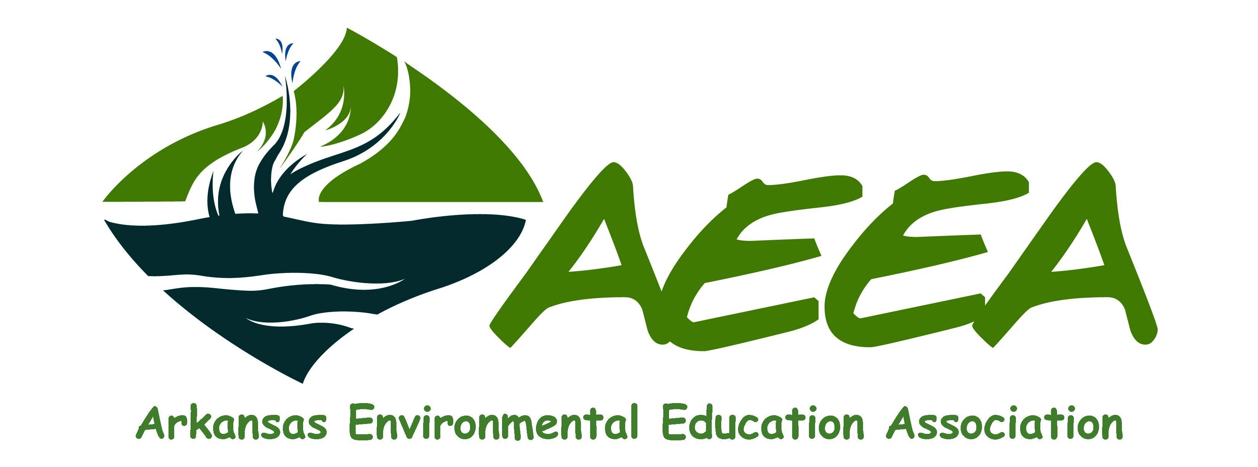

2017 Environmental Grant Program

The Arkansas Environmental Education Association is soliciting proposals of up to $500 for AEEA’s Environmental Grant Program. The program is designed to support, enhance and expand the implementation of environmental education throughout the state of Arkansas by formal and non-formal educators and organizations.

Eligibility Requirements:
Applicants or their organization must be a current member of AEEA.
Applicants must be formal or non-formal educators or represent formal or non-formal education organizations, government agencies, non-profit organizations, or community/civic organizations.
Proposals must be designated for either Formal or Non-Formal education.
Completed proposals must be received by AEEA by the stated deadline.
Grant funds must be allocated and projects completed within the calendar year of the award.

What AEEA Funds:
Proposed projects must address one or more of the following AEEA focus areas:
Environmental Education (formal or non-formal) Environmental Justice
Environmental Sustainability Natural Resource Conservation or Restoration

What AEEA Does Not Fund:
Direct grants to individuals General ongoing operation support including salaries
Political campaigns, events or lobbying activities Projects serving religious purposes
Food and/or beverages Multi-year projects
Expenses incurred prior to receipt of AEEA grant award
Any use not specified or approved in the grant proposal and budget

Timeline:
Application deadline is October 15, 2017.
Award notification and funding available after November 15, 2017.
Final grant report due to AEEA by December 31, 2018.

Grant Submission Requirements:
Complete proposals must be received by AEEA by 5:00pm October 15, 2017.
A completed grant application form must accompany the submitted proposal.
Proposal narrative not to exceed two (2) pages, excluding application form, budget and non-profit documentation.
Proposals may be submitted by mail or email. Email submission must include “AEEA Grant Application” in the subject line to arkansasee@gmail.com .

Grant Application Form

Project Title: ________________________________________________________________________________________________________________________________

Project Category: Formal Education __________ Non-Formal Education __________

Area of Focus (check all that apply):
Environmental Education __________ Environmental Justice __________
Environmental Sustainability __________ Natural Resource Conservation or Restoration __________

Project Date: ________________________________________________________ Amount Requested (max. $500): $_________________________

Organization: _______________________________________________________ Contact Person: _______________________________________________

Street Address: _____________________________________________________________________________________________________________________________

City/State/Zip: ______________________________________________________________________________________________________________________________

Work Phone: ( )_________________________________________________ E-mail: __________________________________________________________

Participant Audience: ______________________________________________ Anticipated Number of Participants: ______________________
I understand that the awarding of all grants and the amount of any grant, shall be subject to the sole discretion of the Arkansas Environmental Education Association. If awarded a grant, I agree to submit a final report as indicated in the grant guidelines. The Arkansas Environmental Education Association shall assume no responsibility or liability for claims of damage of any kind to the property or for claims of injury to any person in connection with this grant.

_______________________________________________________________________
Applicant Printed Name

_______________________________________________________________________ ____________________________________________ ___________________
Applicant Signature Title Date

Submit completed grant application form and proposal by October 15, 2017 to:
AEEA Grants ~ PO Box 1439 ~ North Little, AR 72115 or Email to: arkansasee@gmail.com

Please provide the following information, not to exceed 2 pages:

- Describe the project, including measurable goals and objectives.
- How will the project support, enhance or expand the implementation of EE in your organization or community?
- What are the anticipated outcomes of the project?
- How will the project be evaluated?

In addition, please attach the following:

- Project budget, including how AEEA funds will be utilized.
- A copy of IRS non-profit status determination or other non-profit documentation.

Submit completed grant application form and proposal by October 15, 2017 to:
AEEA Grants ~ PO Box 1439 ~ North Little, AR 72115 or Email to: arkansasee@gmail.com

2017 Grant Criteria

